Examples of Social Media Tools

The following are examples of popular social media tools being used today:


Facebook is a popular social networking tool with more than 1.2 billion users worldwide. In addition to individual personal profiles, Facebook allows businesses, organizations, and causes to create “fan pages” that users can follow. By following a business, organization, or cause, users receive updates and continue to be engaged in current conversations, content, and events the organization is sharing. On Facebook, it’s important to keep content fresh, interesting, and engaging to encourage fan engagement and sharing. www.facebook.com

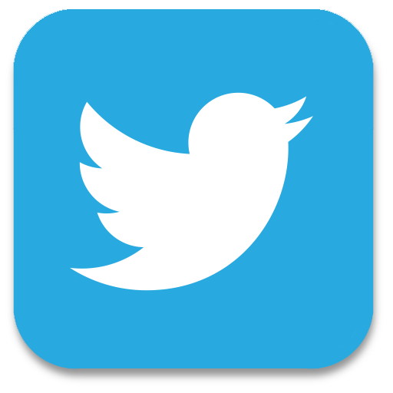
Twitter is a microblogging tool that enables users to post frequent but brief (up to 140 characters) messages called “tweets.” When used well, it can be an effective advocacy and communications tool. Twitter is best used for sharing news and quick updates about your organization, including photos, URLs and video. On Twitter, users can group posts according to relevant topics by using #hashtags, making it easy to share and join conversations happening in the space. www.twitter.com

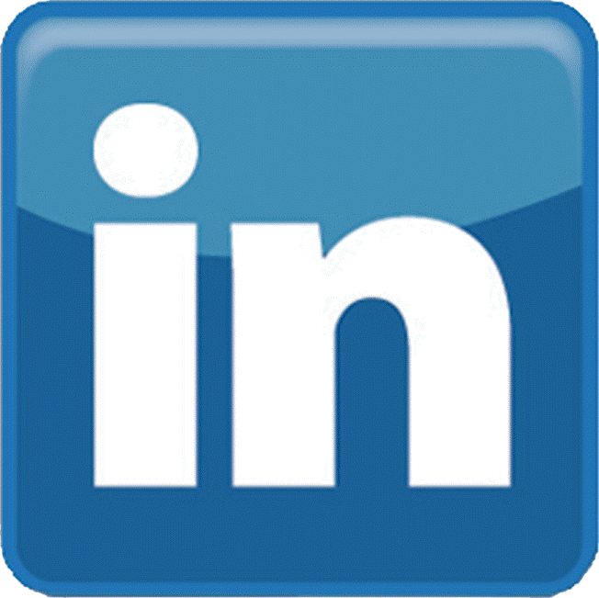
LinkedIn is a business-oriented social network that aims to connect the world’s business professionals. In addition to helping employers connect with potential candidates—and job-seekers with potential employers—business men and women are joining groups of professionals with similar interests to share news, seek advice, and foster discussion related to career advancement and professional topics. Many thought leaders in your community may already be active on LinkedIn. Join groups related to library advocacy, education, community advancement, and the importance of access to technology. www.linkedin.com

YouTube is a great space to share and view videos that relate to your library. By setting up a library page on YouTube, you can post and tag videos that are relevant to your advocacy audiences. You can post a video of library users sharing their success stories in a simple conversational style straight to the camera, share footage of library events, or link to television news stories about the library. More than 1 billion unique users visit YouTube each month. www.YouTube.com


Instagram is a photo-sharing platform made for social sharing through imagery and video that can be easily integrated and shared on other social media platforms. We’re visual learners, meaning people respond better to visual information than text alone. On Instagram, you can use photos and imagery to communicate the value libraries bring to your community by capturing the beauty of the library and the people libraries touch every day. www.instagram.com

Blogging is a way to inject your voice into conversations that are already happening across the Internet. Creating and maintaining a library blog, for example, could help you increase visibility and strengthen your voice. Many public libraries use blogs to publicize new tools the library has acquired, highlight new partnerships, and share success stories of library users. You can also create interactive features on a blog—like answering community questions about the library or encouraging users to submit their own articles to the blog. There are many free platforms you can use to start your own blog, including WordPress: www.wordpress.com

Social Media Reminders & Tips

The following are general rules and tips for using social media effectively:

- Speak their language: One of the important differences between traditional and social media is the ability of social media users to engage in communications with the library. Rather than using social media as a megaphone to push out your information, pay attention to how your audience interacts with others and reach them authentically, using their voice and jargon. Talk about the subjects they’re interested in.

- Be personable: Social media is generally less formal than traditional media. Let your library’s personality shine through in your posts and engage your audience by asking questions, allowing them to vote on a timely library topic, responding to conversations, sharing something funny and linking to quality content from other libraries and library partners.

- Use visuals: The world is an increasingly visual place. People prefer visual descriptions, meaning that posts including images and video receive higher engagement rates (likes, clicks, comments, shares, etc.) than text-only posts. Consider including action photos or featuring people in pictures to put a personality behind your advocacy work and create a more personal connection with your followers.

- Keep it short: Because the environment is cluttered and attentions are fragmented, shorter posts (around 80 characters) and videos (around 30 seconds) receive higher engagement rates.

- Ask yourself: Would I share this? Shareability is the golden rule of creating “social” content. When someone shares your content, they become a third party validator, which is essential to social media success in your advocacy goals. When you post on social media, think like your audience: tap into your shared passion, provide them with new knowledge, seek reactions, entertain, and facilitate self-expression.

- Have a plan and provide a call to action: Align your call to action on social media with your advocacy goals have a simple plan that outlines what you want users to do that will help you achieve your library advocacy goal.

- Make a commitment: Social media is like a relationship—it needs time and attention. It is about listening, as well as sharing, on a regular basis. Pay attention to what your community expects on each platform and base your engagement on your audience’s behavior. For example, Twitter users will not mind seeing multiple posts each day while Facebook users typically don’t want to see more than one daily update.

Creating Social Media Content

Use the following worksheet to practice turning your library story into sharable social content.

Facebook
How could you turn your library story into a Facebook post? Would you include visuals, links, tags? How could you encourage people to like, share, or comment?
Twitter
If you had to tell your library story in a 140-character tweet, what would you say? List two examples.
photos and images
There’s an expression “an image is worth 1,000 words.” What images or graphics would best tell your library story?
Video
If you were creating a video that told your library story, what would it say? Where would you share it? Who would it feature? Would it be live or animated?
other content
What other ideas do you have for how you could turn your library story into sharable content?

Idea Capture
Please use this space to capture ideas and notes from this session.

