MEASURING THE IMPACT OF PUBLIC LIBRARIES:
The value of collecting and using information on how public libraries change people’s lives

Public libraries connect communities to information and the world
Knowledge has the power to transform lives and strengthen communities. Particularly in developing and transitioning countries, people need relevant and timely information to engage and compete in a dramatically changing world. Public libraries provide communities with access to this information and with support so that people can use information to meet their needs. By expanding access to resources such as books, computers, internet, and WiFi, and by offering training on how to use those resources, public libraries empower people to improve their education, livelihood, health, and connection with their communities.

- In many places, public libraries offer the only free public access to computers and the Internet. This benefit becomes increasingly important during times of economic and humanitarian crisis.
- Public libraries reach populations that are often marginalized or underserved by other institutions, such as youth, seniors, women and girls, people living in poverty, racial and ethnic minorities, immigrants, and the unemployed.
- Public library users benefit from the support and guidance of trained library staff.
- Public libraries are often known and respected institutions, created and maintained by governments and responsive to local needs.

What is impact?
The essence of impact is change. For public libraries, impact refers to any change or effect the library has on an individual, group, or community. Measuring impact means looking beyond the ways that the library’s technology or services have expanded – for example, the number of library visitors, the number of book (or other resource) loans, the number computers installed in the library, and the number of library staff who receive formal training – in order to understand the difference that these factors have made to individuals and groups.

“Impact assessment” is the process of measuring changes that may relate to…
Knowledge and skills |  | Examples:  - Library users know how to buy and sell goods or apply for a job online  - Library users have basic computer and internet skills (e.g., turning computer on/of, using a mouse, navigating websites, email, online searches)
Attitudes and perceptions |  | Examples:  - Library users perceive that library computer and Internet access is of benefit to the community  - Library users are more confident about their ability to find jobs/get government benefits
Behavior |  | Examples:  - People visit the library to access e-government services, like paying taxes, securing benefits, or applying for licenses  - Library users use library computer and Internet access to enroll in online courses/seek new qualifications
Quality of life |  | Examples:  - People use library information and support to make positive changes to their health  - People are more engaged in their communities  - People save time and money
Broader social or economic change |  | Examples:  - People have equal access to technology and information  - Better integration of “hard-to-reach” groups in the local community (social inclusion)  - Lower unemployment

While broad social or economic change is often the end goal for public libraries (which they contribute to along with the contributions of many others), aiming for a balance of both long-term and short-term impact is also important. Short-term impacts demonstrate momentum, help to motivate people, illustrate that current efforts are on target, and often have a ripple effect, enabling libraries to build toward the ultimate impact goals. These ultimate impacts are significant for society and they are central to the work of government. As a result, libraries that demonstrate they are contributing to these impacts are more highly valued and recognized by government.

The ripple effect: short-term impacts can lead to broader social or economic change

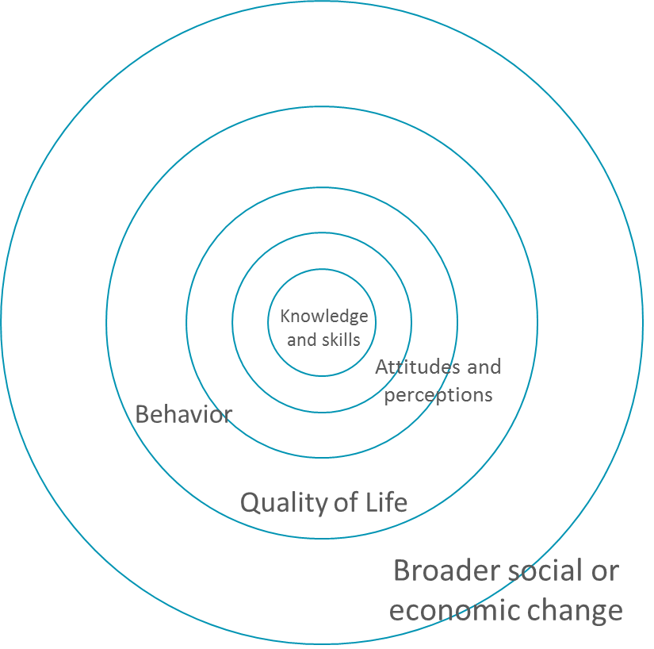

Why is it useful to measure impact?
Measuring impact allows public libraries to show how they contribute to measurable results like job skills developed, education attained, employment found, money saved, and livelihoods improved. This information can help libraries to:

- Understand whether library activities and services are contributing to community impact (e.g., the types of changes listed in the table above)
- Call attention to changes that can help libraries more effectively meet their goals
- Guide the formation of new partnerships or supporting existing partners
- Use evidence of impact to advocate for continued support for public libraries

When libraries measure impact, it can also help other stakeholders. Library visitors benefit from the quality of life improvements mentioned earlier, and local and national government can bolster its reputation among constituencies for partnering with and supporting libraries in making progress toward development goals.

What should we measure?
The impact that public libraries have on library users can span a variety of issue areas including, but not limited to the following:

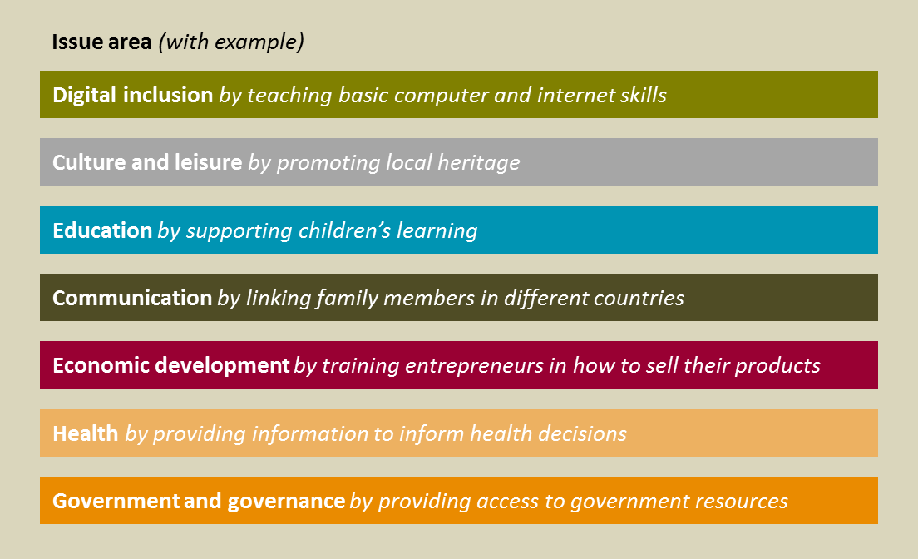

Libraries can seek to understand their impact in these areas by identifying indicators that help to quantify the ways that libraries have made a difference for those they serve. They can also gather qualitative information such as stories, anecdotes and observations.

It is important to choose a short set of information to measure based on what will be most powerful in the local context for advocacy and learning purposes – for instance, someone in the ministry of agriculture will be most interested in the impact that libraries have on farmers’ livelihoods. No single indicator will be effective in every context.

The following is a short list of example indicators that have been found to be particularly persuasive to policymakers, or most useful for designing and improving library services. Note that library services can include access to books, WiFi, computers, Internet, training or assistance from library staff or an outside expert, and/or other resources, training and events.

Number/percentage of library visitors who:
- use the Internet at the public library
- learn basic computer and Internet skills at the public library
- are more involved in their community as a result of the services provided at the public library
- save money as a result of technology or services provided by the public library
- read more as a result of their access to the public library
- find job listings or employment opportunities using services at the public library
- search for health information using public library services

Number/percentage of public access computer/ Internet users:
- For whom the library is the only free point of access to the Internet
- communicate more with family and friends as a result of technology at the public library
- buy or sell a product or service using technology at the public library
- use e-government services using technology at the public library
- receive money/subsidies/support owed to them by the government as a result of their ability to access government services using technology at the public library

How to collect impact data?
At a very basic level, collecting impact data involves the following methodology:

- Determine what to measure by identifying information that will be important to policy- and decision-makers such as the ministries responsible for libraries (e.g., culture, information and communications) and/or important for understanding how to design and improve library services
- Create a survey in the appropriate local language that can be used to collect information for the identified indicators. This survey can be administered in paper format or by using a tablet or mobile device (see Example Impact Measurement Survey in appendix)
- Administer the survey to a random sample of public library visitors (ideally at regular intervals – e.g., once a year – in order to measure changes over time)
- Analyze and synthesize the data that is collected
- Examine the data to develop key messages and insights that will resonate with key audiences (e.g., policymakers)
- Use the data about the impact of library services to persuade policy- and decision-makers and/or to design or improve library services. Often times, pairing quantitative (numbers) data with a story is the most powerful way to talk about the library’s impact

For many libraries, analyzing and synthesizing the data and then developing key messages and insights are the tasks they find most challenging. In this case, it can be helpful to form partnerships with local academic institutions that can provide assistance with the analysis.

For additional information on how to collect impact data, see list of resources in the Appendix: How to Learn More.

How to use impact data to overcome library challenges
Public library partners, governments, aid organizations, and others can use impact data to demonstrate the value of public libraries and learn more about engaging with libraries to meet community development goals.

Library Challenge |  | Approach to address challenge
Inadequate funding; libraries cannot afford the cost of the goods and services they need to support the community |  | Library staff and other stakeholders/allies can use data about the impact of library services to advocate for national or local government to create new funding mechanisms for libraries.
High librarian turnover/lack of leadership |  | Library staff and other stakeholders/allies can use data  about the impact of library services to  reinforce the importance of library staff, raise  the visibility of the profession, and recruit  motivated library staff and leaders
Outdated computers or limited broadband access throughout the library system |  | Library staff and other stakeholders/allies can use data about the impact of library broadband access to advocate for policies or guidelines that determine how often technology should be replaced, ensure that users have sufficient access, and/or require Wi-Fi capabilities, which would increase the number of people benefiting from library services.

Appendices: Methodological Guidelines, Links, Case Studies, Resources, Survey Tools

By visiting www.publiclibraryimpact.org, you can find additional materials, including:

- Success stories describing how public libraries around the world have begun measuring user outcomes and positive results, such as more potent advocacy or increased community impact.
- Methodological Guidelines for measuring impact
- Sample User Outcome Survey for Public Libraries
- Tools, Resources and Links to help you learn more

This is an example framework for the types of issue areas public libraries may affect. Other ways that libraries might frame their impact could include: job skills, lifelong learning, civic/community engagement, summer reading, agriculture, government and legal services, management of finances, social connections, human services, public access to information, capacity building, and/or other areas.
Note that there are free and low cost tools available to help libraries measure impact. Visit www.publiclibraryadvocacy.org for more information.

